# **12 Physics Learning Task Wind Turbine Alternator & Electromagnetic Theory Investigation**

### **Unit 3 Outcome 3** Analyse and evaluate an electricity generation and distribution system.

### **Introduction**

A wind turbine’s alternator generates AC electricity as its blades spin. The magnetic field inside the alternator continuously changes over time, inducing an **electromotive force (emf)** in the coils. Wind turbines have aerodynamically shaped blades which rotate as the wind blows, causing a central shaft to spin. The rotating shaft is connected to an alternator which comprises of a rotor containing strong permanent magnets, surrounded by stationary coils of wire. As the rotor spins, the magnets move past the coils, continuously changing the magnetic field passing through the coils. Using this real-world scenario, explore the following questions:

### **Variation in magnetic flux**

1. How does the orientation of the magnetic field relative to the coil affect the **magnetic flux** in a wind turbine alternator?
2. If the magnetic field strength inside the alternator is **0.5 T**, and the coil’s effective area is **0.2 m²**, how would you calculate the maximum **magnetic flux**?
3. What factors influence the **variation of magnetic flux** in an alternator during rotation, and how does this impact power generation?

### **Electromagnetic induction and energy generation**

1. How does the **rate of change of magnetic flux** affect the amount of **induced emf** in an alternator?
2. Suppose the alternator has **500 loops**, and the magnetic flux changes from **0.1 Wb to 0 Wb in 0.02 seconds**. How can you apply **Faraday’s Law** to calculate the induced emf?
3. How would increasing the number of **coil loops** impact the generated voltage? What are the practical limitations of increasing coil loops in real-world wind turbine alternators?

### **AC vs. DC Generation & Energy Applications**

1. How does an **alternator** generate **AC voltage**, and why does it use **slip rings** instead of a **split-ring commutator**?
2. In what ways does a **DC generator** differ in its design and output compared to an **alternator**? What advantages and disadvantages does each have?
3. Why do **solar panels produce DC power**, and how does an **inverter** play a crucial role in integrating solar energy into household electricity systems?
4. What are the **benefits and challenges** of using wind and solar energy to generate electricity on a large scale?

**Assessment Rubric**

|  |  |  |  |  |
| --- | --- | --- | --- | --- |
|  | **1** | **2** | **3** | **4** |
| **explains concepts** | defines terms e.g. magnetic flux is the strength of magnetic field in given area | explains concepts e.g. how the orientation of a magnetic field affects magnetic flux | makes connections between ideas e.g. how changing magnetic flux affects power generation | applies understanding to real world scenario |
| **Applies maths principles** | lists formulae | defines variables in formula | links formulae to relevant concepts | uses formula relationships to help explain ideas. E.g. as P = VI, reducing current reduces power loss |
| **Uses evidence** | states ideas | supports ideas with a physics principle or theory | uses evidence from multiple sources, e.g. calculations and theories | justifies ideas with mathematical models e.g. insert values into formula |
| **Communicates ideas** | lists all ideas with unstructured approach | states main idea and then supporting details | uses clear and direct language e.g. eliminates unnecessary words | organises information by using dot points and grouping ideas |
| **Works in a team** | listens to others | explains own thinking and asks questions to clarify understanding | builds on ideas from others | leads others in fostering teamwork |

**Suggested Answers: Wind Turbine Alternator & Electromagnetic Theory Investigation**

**Magnetic Flux & Its Variations**

1. **How does the orientation of the magnetic field relative to the coil affect the magnetic flux in a wind turbine alternator?**

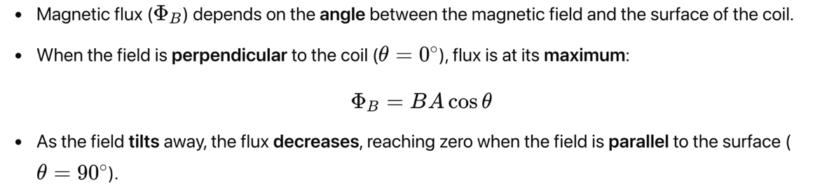

1. **How would you calculate the maximum magnetic flux? How does flux change when the field is not perpendicular?**

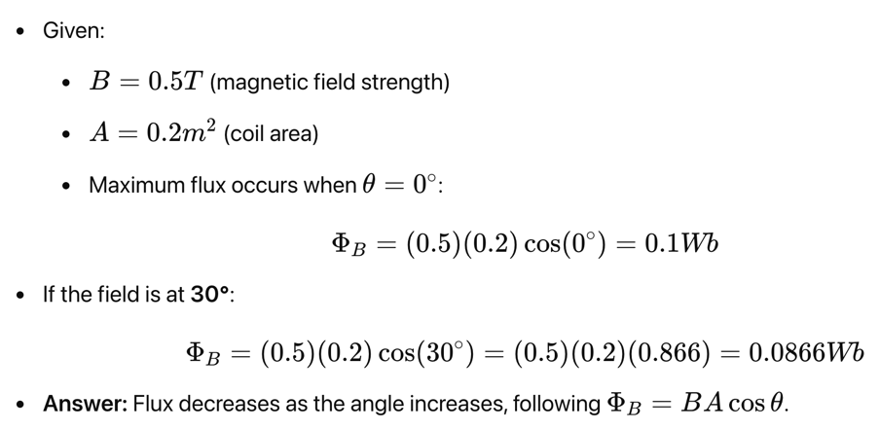

1. **What factors influence the variation of magnetic flux in an alternator during rotation, and how does this impact power generation?**

* **Rotation speed:** Faster spinning changes flux more rapidly, increasing induced voltage.
* **Magnetic field strength:** Stronger fields produce higher flux and more induced emf.
* **Coil area & orientation:** Larger coil area increases flux, while angle changes affect its magnitude.

**Electromagnetic Induction & Energy Generation**

1. **How does the rate of change of magnetic flux affect the amount of induced emf in an alternator?**

**Faraday’s Law of induction**

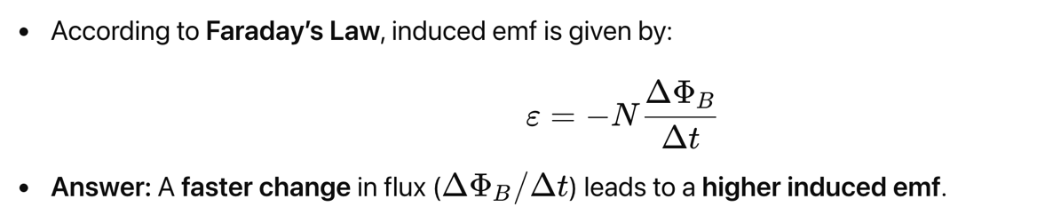

1. **Applying Faraday’s Law of induction to calculate induced emf:**

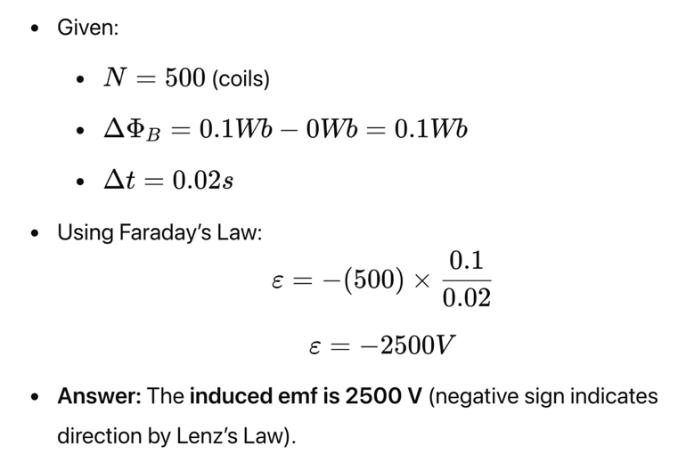

1. **How would increasing the number of coil loops impact generated voltage? What are the practical limitations?**

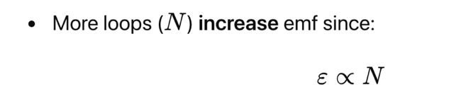

**Limitations:**

* More loops increase resistance, reducing efficiency.
* Larger coils require more space and materials.
* Mechanical limitations (e.g., heating and durability).
* **Answer:** Increasing coils boosts voltage but introduces practical constraints like resistance and space.

**AC vs. DC Generation & Energy Applications**

1. **How does an alternator generate AC voltage, and why does it use slip rings instead of a split-ring commutator?**

* **AC alternators:**
* A **rotating coil** in a magnetic field changes flux periodically.
* This induces an **alternating emf** (voltage switches direction).
* **Slip rings** allow continuous current flow without reversing the connections.

**DC generators:**

* Use a **split-ring commutator** to **reverse** the connection each half-cycle.
* This keeps current flowing in **one direction** (DC).
* Slip rings maintain AC output, while split-ring commutators force a unidirectional current for DC.

1. **In what ways does a DC generator differ in design and output from an alternator? What advantages and disadvantages does each have?**

* **Alternators (AC):**
* Produce **alternating current** (AC).
* Efficient for **power transmission** over long distances.
* Used in **power plants, wind turbines, and vehicles**.
* **DC Generators:**
* Produce **direct current** (DC).
* Used in **batteries, small electronics, and some motors**.

**Advantages & Disadvantages:**

| Type | Advantages | Disadvantages |
| --- | --- | --- |
| **Alternator** | Efficient, requires less maintenance | Needs rectification for DC applications |
| **DC Generator** | Direct power source for electronics | More wear due to commutators, lower efficiency |

1. **Why do solar panels produce DC power, and how does an inverter play a crucial role in household electricity systems?**

* **Solar Panels & DC:**
* **Photovoltaic cells** generate electricity through the **photoelectric effect**.
* The movement of electrons produces **direct current (DC)**.
* **Need for an Inverter:**
* Most household appliances run on **alternating current (AC)**.
* **Inverters** convert **DC to AC** for compatibility.
* Solar panels naturally generate DC, but inverters are needed to convert it to usable AC power.

1. **What are the benefits and challenges of using wind and solar energy for electricity generation?**

**Benefits:**

* **Renewable & sustainable** (no depletion of resources).
* **Environmentally friendly** (no greenhouse gas emissions).
* **Low operating costs** after installation.
* **Challenges:**
* **Intermittent supply** (depends on wind/sunlight conditions).
* **Storage & transmission** (batteries and grids must adapt).
* **High initial cost** for infrastructure.