# **Unit 2 AOS2 Options Project**

# Task Outline

It has been predicted that 75% of future jobs will require skills in Science, Technology and Mathematics and it is known that Physics is a great Science option because it provides the foundation for many careers.

However, in Victoria only about 15% of VCE students study Physics. One way to increase participation in Physics is to encourage students interest from a young age. In this task, you will design an activity for students in primary school about a Physics topic that aims to increase students understanding and interest.

|  |
| --- |
| The requirements of the activity are;   * The learning content will be delivered in a way that primary aged students can understand * You will need to use active learning strategies, that is they will learn by doing an activity. |

You will work in a team of four or five to create a series of learning experiences for students in Years 3 - 5.

The flow chart below shows the three main sections in the assignment.

Relevant key 
knowledge 
descriptor 
Description 
of resources 
and 
activities 
Evaluation 
of activities 
to content 
Address all points within the 
VCAA study design 
Outline the sequence of 
lesson including any 
introd uctory materials, 
resources or worksheets 
Link lesson to material, as 
well as link to 
future/ previous lessons. 

Your team needs to choose **ONE** topic from the options listed in the table below.

## Topic Options

|  |  |  |
| --- | --- | --- |
| [Is there life beyond Earth’s Solar System?](https://myaitken.fireflycloud.net.au/science/year-11/physics/unit-2/assessment/aos2-options-1/is-there-life-beyond-earths-solar-system) | [How do forces act on the human body?](https://myaitken.fireflycloud.net.au/science/year-11/physics/unit-2/assessment/aos2-options-1/how-do-forces-act-on-the-human-body) | [How can AC electricity charge a DC device?](https://myaitken.fireflycloud.net.au/science/year-11/physics/unit-2/assessment/aos2-options-1/how-can-ac-electricity-charge-a-dc-device) |
| [How do heavy things fly?](https://myaitken.fireflycloud.net.au/science/year-11/physics/unit-2/assessment/aos2-options-1/how-do-heavy-things-fly) | [How do fusion and fission compare as viable nuclear energy power sources?](https://myaitken.fireflycloud.net.au/science/year-11/physics/unit-2/assessment/aos2-options-1/how-do-fusion-and-fission-compare-as-viable-nuclear-energy-power-sources) | [How is radiation used to maintain human health?](https://myaitken.fireflycloud.net.au/science/year-11/physics/unit-2/assessment/aos2-options-1/how-is-radiation-used-to-maintain-human-health) |
| [How do particle accelerators work?](https://myaitken.fireflycloud.net.au/science/year-11/physics/unit-2/assessment/aos2-options-1/how-do-particle-accelerators-work) | [How can human vision be enhanced?](https://myaitken.fireflycloud.net.au/science/year-11/physics/unit-2/assessment/aos2-options-1/how-can-human-vision-be-enhanced) | [How do instruments make music?](https://myaitken.fireflycloud.net.au/science/year-11/physics/unit-2/assessment/aos2-options-1/how-do-instruments-make-music) |
| [What are stars?](https://myaitken.fireflycloud.net.au/science/year-11/physics/unit-2/assessment/aos2-options-1/what-are-stars) | [How can performance in ball sports be improved?](https://myaitken.fireflycloud.net.au/science/year-11/physics/unit-2/assessment/aos2-options-1/how-can-performance-in-ball-sports-be-improved) | [How does the human body use electricity?](https://myaitken.fireflycloud.net.au/science/year-11/physics/unit-2/assessment/aos2-options-1/how-does-the-human-body-use-electricity) |

## **Part A: Complete research questions**

Each group member will need to complete a separate set of dots points from the VCE study design for your topic. All the dot points much be completed for the group. A research grid will be used to summarise your information. All parts of this task must be completed electronically.

**Due: Monday, September 7th**

## **Part B: Plan the activity**

You need to plan an activity using the Lesson Plan template provided. The activity must incorporate interactive resources that will help to consolidate students understanding. Your target audience are primary school students.

**Due: Friday, September 11th**

## **Part C: Develop and Design your resource**

Each group member will then need to develop one resource that can be used by a group of primary school students.

**Due: Friday, September 11th**

## **Part D: Demonstrating your resource**

Each group member will be required to create a OneNote page that works like a website to include their embedded multimedia (powerpoint, video, storyboard, etc.) of their resource would be used with primary school students.

**Due: Thursday, September 17th**

## **Timeline**

* Lesson 1: Introduce the task, form groups, choose topic, allocate VCAA dot points, start research
* Lesson 2: Work on research grid
* Lesson 3: Work on research grid
* Lesson 4: Finalise research grid (show link between theory)
* Lesson 5: Complete activity plan
* Lesson 6: Develop resource
* Lesson 7: Develop resource
* Lesson 8: Demonstrate resource
* Lesson 9: Demonstrate resource & submission of assessment

## **Project Documentation**

All your research and activity planning is to be completed in your OneNote folder.

## **Assessment Rubric**

|  |  |  |  |  |  |
| --- | --- | --- | --- | --- | --- |
|  | **Identifies links between evidence from different sources**    Connections are shown in the research grid between the evidence by using a mindmap. |  |  | **creates resources**    Creates, designs or builds a resource. |  |
| **explains validity of evidence**    The validity considers the credentials of the person, company or organisation. | **uses multiple types of evidence**    Different types of evidence (primary, secondary or tertiary sources) are used | **Explains links between ideas**    Explains how the information covered in the allocated dot points relate to the entire topic option. |  | **uses resources to explain ideas**      Resources encourage active student learning; e.g. student participation and collaboration. | **identifies links between ideas**      Identifies links between an activity and the topic content |
| **finds relevant evidence**    The evidence is related to the topic. | **defines types of evidence**    The evidence is categorised as primary, secondary or tertiary. | **identifies links between ideas**    Identifies links between allocated dot points. | **uses required style**    Includes references, in-text citations and uses the required style. | **uses relevant resources**    Resources are relevant to topic option. | **explains ideas and activities**    Explains how an activity supports the teaching of the content. |
| **finds evidence**    Evidence is inserted into grid. | **uses evidence**    Many sources are included in the research grid. | **discusses ideas**    Separately discusses each dot point. | **lists sources**    Includes references, however doesn’t use required style. | **uses resources**      Submits resources for assessment. | **uses ideas and designs activities**    Identifies the ideas and activities that will be used in the lesson. |
| **evaluates evidence** | **analyses evidence** | **evaluates ideas** | **references sources** | **uses resources** | **plans** |

## **Research Grid**

**Instructions**

1. Insert the option your group has selected and the names of your group members into Table 1.
2. Insert all of the dots points for your option and indicate which group member has been allocated to them into Table 2.
3. Complete the research grid in Table 3.
   1. Find a source that helps to answer one of the key knowledge descriptors.
   2. Identify whether the source is primary, secondary or tertiary and if it is scientific or non-scientific.
   3. Evaluate the validity of the source.
   4. Use different colours to show the links between the questions in Table 2 and the information in the blue column in Table 3.

Table 1.

|  |  |
| --- | --- |
| Option Selected |  |
| Group members |  |

Table 2.

|  |
| --- |
| Insert the dot points for your option and who has been allocated to it. |

Table 3. An example of how to complete the Research Grid is provided in the first row.

|  |  |  |  |  |
| --- | --- | --- | --- | --- |
| **Source**  •Use Harvard style.  •Include intext citations in brackets. | **P/S/T**  P- primary  S- secondary  T- tertiary | **S/NS**  scientific or non- scientific | **Summary of relevant information**  (Use highlighting to make links between the question and the information) | **Evaluate validity**  Provide an explanation of whether the evidence is valid.   * What are the author’s credentials? * Is the author affiliated with a recognized research institution? * What is the publication date? * Is there any bias?   Examine evidence (Is it peer-reviewed or edited by a publisher?) |
| Lee FH, A population based 16 year study on the risk factors of surgical site infection, Medicine, 2015, (4), [**www.ncbi.nlm.gov**](http://www.ncbi.nlm.gov), [date accessed 15th June 2020] | *Note: This is a secondary resource as the information is from scientists reporting the results of their own research.*  S | *Note: This is a scientific article as it based on research data*  S | *Note: The student has highlighted the text with different colours to show how the information connects to different key knowledge descriptors*   postoperative recipient graft site infection is a possible risk factor when receiving a bone graft. Using a study of 1.3 million people who underwent bone graft surgeries from 1997-2013 shows that 3% of these people contracted the infection.   People prone to contracting an infection post surgery were seen to be males of an older age (roughly 40 or older) has a longer hospital stay, had a lower income or suffered from a “chronic disease (tuberculosis [TB]; diabetes mellitus [DM]; acquired immunodeficiency syndrome [AIDS])” | The authors, Fang-Hsin Lee, PhD, Po-Chuan Shen, MD, I-Ming Jou, MD, PhD, Chung-Yi Li, PhD, and  Jeng-Long Hsieh, PhD all have a PhD in areas related to this topic.  All authors are a part of a medical team in Baltimore called NCBI. The journal is also edited by James Kellam.  This article presents their opinion and findings based on evidence and statistics from their own research. The authors could still have been bias in their findings in that they could report results only on one specific group of people. However, it is likely that the evidence is valid as it is a part of a research journal that was published after 16 years of research. |
|  |  |  |  |  |

**Research Guide**

Reference: This material is based on information from the Learning Centre, University of Sydney (2000) Developing and Supporting an Argument, date accessed 31st August 2015.

During the research phase, it is important to use different types of sources and identify whether the evidence is valid. This information needs to be included in the Research Grid and is explained using the following questions.

**Question 1. What type of sources and evidence is suitable to use in my research?**

Sources can be divided into three main groups.

|  |
| --- |
| * + **Primary sources** are original materials.   e.g. laboratory notes, survey research, letters, diaries and photos.   * + **Secondary sources** are evaluations of primary sources.   e.g. scientific reports, journal articles, magazine articles and newspaper articles.   * + **Tertiary sources** are a compilation of both primary and secondary sources.   e.g. website, general textbooks, encyclopaedias and technical manuals. |

In the discipline of Science, evidence is also divided into the categories; scientific and non-scientific.

|  |
| --- |
| * + **Scientific evidence**     - journal articles, textbooks and encyclopaedias that are based on research data   + **Non-scientific evidence**      - personal experiences, opinions and anecdotes – This type of evidence is often in blog sites, magazines for the general community and the media. |

**Question 2: How can I identify whether the evidence is valid?**

Not all evidence is equally valid or reliable and is often dependent on where it is from. It is important to check the credentials of the author(s) to determine whether the evidence is valid.

|  |
| --- |
| Evidence can be from;   * + government agency - personal blog - commercial company - media article |

**Question 3: How can I reference my sources?**

All the information used in the Research Grid and the poster must be referenced using the Harvard Style. You can use the Bibliography Generator on MyAitken/Library Resources to help write the bibliography and the in-text citation in the correct format.

|  |
| --- |
| **An example of how to reference in Harvard style for an encyclopedia**   * author (date) title of article, book title, web address (URL), [date accessed]. * Note: You only need to include the first part of the url in your reference.   Williams (2016) Multiple Myeloma, Encyclopedia Britannica, [www.school.eb.com.au](http://school.eb.com.au/levels/high/article/54243), [date accessed 6th April 2020]. |
| **An example of an in-text citation**  Multiple Myeloma is similar to Leukaemia in that there is an increase of abnormal cells in the bone marrow which results in a reduction in the immune system as the normal function of the bone marrow is compromised (Williams, 2016). |

# **Lesson Plan**

**Instructions**

1. You need to plan an activity using the Lesson Plan template provided.
2. The activity must incorporate interactive resources that will help to consolidate students understanding.
3. Your target audience are primary school students in years 3 - 5

|  |  |  |
| --- | --- | --- |
| ***Relevant key knowledge descriptor*** | ***Description of resources and activities*** | ***Evaluate and link activities and resources to content***   * 1. Evaluate the relevance of the activity or resources to the overall aim of the lesson.   2. Identify the links between the content covered in the lesson and how the activity or resources supports the teaching of the content. |
|  |  |  |

# **Key knowledge descriptors divided into sets**

# **Reference:** Information taken from 2016-2021 VCAA VCE Physics Study design

# **What are stars?**

Observations of the night sky have changed over time from using just the naked eye to the use of sophisticated instruments. This option involves the examination of the birth, life and death of stars in the Universe. Students explore how the properties of starlight can provide information, including the star’s distance from Earth, its temperature, composition, age and future.

On completion of this unit the student should be able to apply concepts of light and nuclear physics to describe and explain the genesis and life cycle of stars, and describe the methods used to gather this information.

## **Key knowledge**

**Astronomical measurement**

#### Set 1 - Electromagnetic radiation & waves

* explain the use of electromagnetic radiation in collecting information about the Universe
* identify all electromagnetic waves as travelling at the same speed, c, in a vacuum
* 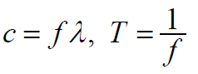calculate wavelength, frequency, period and speed of light:

#### Set 2 - Methods of measurement

* identify spectroscopy as a tool to investigate the light from stars, and interpret and analyse spectroscopic data with reference to the properties of stars
* apply methods used for measurements of the distances to stars and galaxies (standard candles, parallax, red shift) to analyse secondary data.

**Starting References**

* [Hubble Telescope](https://hubblesite.org/contents/articles/the-electromagnetic-spectrum)
* [Khan Academy](https://www.khanacademy.org/science/physics/light-waves/introduction-to-light-waves/a/light-and-the-electromagnetic-spectrum)

**Classification of stars**

#### Set 3 - Classification of stars

* describe the Sun as a typical star, including size, mass, energy output, colour and information obtained from the Sun’s radiation spectrum
* identify the properties of stars, including luminosity, radius and mass, temperature and spectral type, and explain how these properties are used to classify stars
* explain nuclear fusion as the energy source of a star including: E = mc2
* distinguish between the different nuclear fusion phenomena that occur in stars of various sizes.

**Starting references:**

* [National Geographic](https://www.nationalgeographic.com/science/space/universe/stars/)

**Stellar life cycle**

#### Set 4 - Stellar life cycle

* apply the Hertzsprung–Russell diagram as a tool to describe the evolution and death of stars with differing initial mass
* relate the formation of stars to the formation of galaxies and planets
* investigate selected aspects of stellar life cycles by interpreting and applying appropriate data from relevant databases.

#### Set 5 - Black holes & Galaxies

* describe future scenarios for a star, including white dwarfs, neutron stars and black holes
* explain the event horizon of a black hole and use the equation below to calculate the Schwarzschild radius

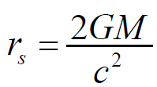

* describe the effects of the gravitational fields of black holes on space and time
* compare the Milky Way galaxy to other galaxies with different shape, colour or size
* explain and analyse how the chemical composition of stars and galaxies is used to determine their age

**Starting References:**

* [NASA](https://science.nasa.gov/astrophysics/focus-areas/how-do-stars-form-and-evolve)

# **Is there life beyond Earth’s Solar System?**

In this option students are introduced to ways that the question about life beyond Earth’s Solar System is investigated by astronomers. Students consider the likelihood of life, including intelligent life, beyond the Solar System, the methods used to find suitably habitable planets, and how the search for life beyond the Solar System is conducted. They examine how telescopes are deployed to observe starlight from across our galaxy and to detect possible signals from other life.

On completion of this unit the student should be able to apply concepts of light and nuclear physics to describe and explain the genesis and life cycle of stars, and describe the methods used to gather this information.

**Key knowledge**

**Information from beyond Earth’s Solar System**

#### Set 1 - Spectrums and Spectroscopy

* identify the spectrum of electromagnetic radiation as the basis for all observations of the Universe
* explain how emission and absorption line spectra are produced with reference to the transition of electrons between energy levels of the atom
* identify spectroscopy as a tool to investigate the light from stars, and interpret and analyse spectroscopic data with reference to information from beyond our Solar System

**Starting reference**

* [Hubble Telescope](https://hubblesite.org/contents/articles/the-electromagnetic-spectrum#targetText=Infrared%20light%20is%20used%20to,spectrum%20our%20eyes%20can%20see)

#### Set 2 - Locating extrasolar planets

* 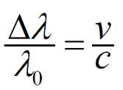compare methods of exoplanet detection including astrometric, radial velocity, transit method and microlensing, referring to databases that differentiate for size, eccentricity and radius
* explain and apply Doppler shift including spectral shift and ‘wobble’ of planetary systems using:
* investigate how the composition of an exoplanet can be determined using spectral analysis.

**Starting reference**

* [NASA](https://exoplanets.nasa.gov/alien-worlds/ways-to-find-a-planet/)

#### Set 3 - Conditions for life beyond Earth’s Solar System

* explain the presence of liquid water as determining the habitable zones of a star system and the most likely place for life
* explain the origins of life in the Universe as having come from organic molecules in space, or as originating on Earth or an Earth-like planet through reactions of elements and compounds.

**Starting reference**

* [Life in space](https://www.nhm.ac.uk/discover/eight-ingredients-life-in-space.html)

#### Set 4 - Possibility of life beyond Earth’s Solar System

* explain the use of the Fermi paradox to question the possibility of life outside Earth’s Solar System and identify its counter arguments
* apply the Drake equation (below) as a way of predicting the likelihood of life existing in the Universe by making reasonable assumptions based on evidence and speculation

#### Set 5 - Searching for Extra-terrestrial intelligence

* distinguish between targeted and untargeted searches for extra-terrestrial intelligence (ETI), and describe optimising strategies including where to look and how to ‘listen’ with reference to choice of frequency and bandwidth
* explain why the radio spectrum is the best section of the electromagnetic spectrum to search the sky for possible ETI signals, including the cosmic radio window and the use of radio astronomy in the search
* explain the nature of information that humans transmit beyond Earth to signal that intelligent life exists on Earth.

**Starting references**

* [SETI](https://www.seti.org/if-extraterrestrials-are-out-there-why-havent-we-found-them), [Drake equation](https://www.seti.org/drake-equation-index)

# **How do forces act on the human body?**

This option involves the application of mechanical theories and concepts to living systems with emphasis on the human body, particularly its movement, structure and function. Students observe the effects of forces acting upon a material and evaluate data relating to changes to the material. They investigate properties of structures and materials in the context of the human body and in the development and design of prosthetics.

On completion of this unit the student should be able to analyse the physical properties of organic materials including bone, tendons and muscle, and explain the uses and effects of forces and loads on the human body.

**Key knowledge**

#### Set 1 - Forces in the human body

* 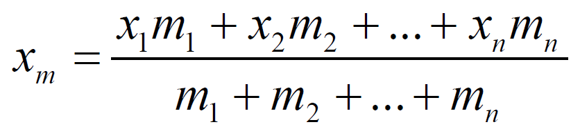identify different types of external forces, including gravitational forces, that can act on a body to create compression, tension and shear
* apply centre of mass calculations to a body or system:
* investigate and apply theoretically and practically translational forces and torques (τ = r F ) in simple lever models of human joints under load.

**Starting References**

* Heineman Physics 11 Ch 14 p489

#### Set 2 - Materials in the human body

* 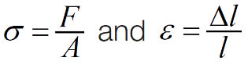calculate the stress and strain resulting from the application of compressive and tensile forces and loads to materials in organic structures including bone and muscle using:

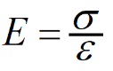compare the behaviour of living tissue under load with reference to extension and compression, including Young’s modulus:

* investigate how the behaviour of living tissue under load compares with common building materials, including wood and metals

#### Set 3 - Comparison of materials

* investigate the suitability of different materials for use in the human body, including bone, tendons and muscle, by comparing tensile and compressive strength and stiffness, toughness, and flexibility under load
* calculate the potential energy stored in a material under load (strain energy) using area under stress versus strain graph
* investigate the elastic or plastic behaviour of materials under load, for example skin and membranes.

**Starting References**

* Heineman Physics 11 Ch 14 p489

#### Set 4 - Materials used to replace body parts

* investigate the development of artificial materials and structures for use in prosthetics, including external prostheses for the replacement of lost limbs, and internal prostheses such as hip or valve replacements
* identify the difficulties and problems with implanting materials within the human body
* compare the performance of artificial limbs with natural limbs with reference to function and longevity.

**Starting Resources**

* Heineman Physics 11 Ch 14 p489

# **How can AC electricity charge a DC device?**

This option investigates the processes involved in transforming the alternating current delivered by the electrical supplier into low voltage direct current for use with small current electrical devices. Students investigate a variety of circuits to explore processes including transformation, rectification, smoothing and regulation. They use a variety of instruments to observe the effects of electricity.

On completion of this unit the student should be able to construct, test and analyse circuits that change AC voltage to a regulated DC power supply, and explain the use of transducers to transfer energy.

**Key knowledge**

#### Set 1 - 240 V AC to 6 V DC

* analyse the role of the transformer in the power supply system including the analysis of voltage ratio: (below) (not including induction or its internal workings)

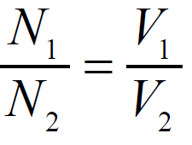

* explain the effect of capacitors with reference to voltage drop and current change when charging and discharging (time constant for charging and discharging, τ = RC ) leading to smoothing for DC power supplies

#### Set 2- 240 V AC to 6 V DC

explain the use of diodes in half-wave and full-wave bridge rectification

describe the use of voltage regulators including Zener diodes and integrated circuits

#### Set 3 - 240 V AC to 6 V DC

analyse systems, including fault diagnosis, following selection and use of appropriate test equipment

interpret a display on an oscilloscope with reference to voltage as a function of time.

**Starting references**

* [All About Circuits](https://www.allaboutcircuits.com/textbook/semiconductors/chpt-3/rectifier-circuits/)
* [Khan academy](https://www.khanacademy.org/science/physics/circuits-topic/circuits-with-capacitors/v/capacitors-and-capacitance)

#### Set 4- Data transfer

* apply the use of heat and light sensors such as thermistors and light-dependent resistors (LDRs) to trigger an output device such as lighting or a motor
* evaluate the use of circuits for particular purposes using technical specifications related to potential difference (voltage drop), current, resistance, power, temperature and illumination

#### Set 5- Data transfer

* compare different light sources (bulbs, LEDs, lasers) for their suitability for data transfer
* explain the use of optical fibres for short and long distance telecommunications.

**Starting references**

* [GCSE Science](http://www.youtube.com/watch?v=fJjeo5nYUyU)
* [Institute of Physics](https://www.iop.org/cs/page_43644.html#gref)

# **How do heavy things fly?**

This option enables students to explore the aerospace principles that underpin the development of controlled powered flight and the application of these principles to aerospace design. Students observe how different forces affect flight. They investigate the principles of aerodynamics and flight control and how these principles are utilised in the design and operation of aircraft.

On completion of this unit the student should be able to apply concepts of flight to investigate and explain the motion of objects through fluids.

**Key knowledge**

#### Set 1 - Aerodynamics

* model the forces acting on an aircraft in flight as lift, drag, the force due to gravity and thrust
* identify aerodynamic forces as arising from the movement of fluid over an object

#### Set 2 - Aerodynamics

* explain the production of aerodynamic lift with reference to:
* Bernoulli’s principle and pressure differences
* conservation of momentum and downwash
* compare contributions to aerodynamic drag, including skin friction, form and lift-induced

#### Set 3 - Aerodynamics

* explain the changes in aerodynamic behaviour at supersonic speeds, including compressibility, shock wave formation and increase in drag
* explain the production of thrust with reference to Newton’s laws of motion
* investigate how it is possible for an aircraft to generate lift when flying upside down.

**Starting Reference**

* [NASA Shape effects on lift](https://www.grc.nasa.gov/www/k-12/airplane/shape.html)

#### Set 4 - Manipulating flight

* calculate lift and drag forces acting on an aircraft:
* lift 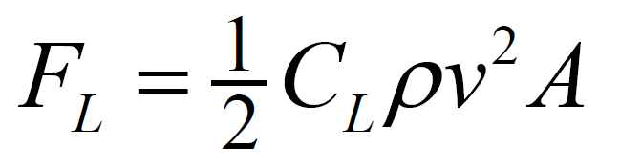
* drag 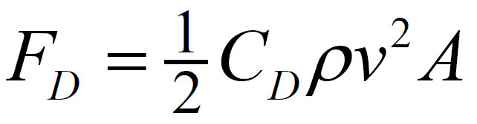
* investigate theoretically and practically the variation of lift coefficient with angle of attack, including identification of stall
* model aerodynamic forces as acting at the centre of pressure and the force due to gravity as acting at the centre of mass
* calculate the torque applied by a force acting on an aircraft: 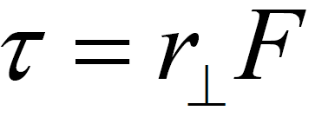

#### Set 5 - Manipulating flight

* describe the roles of the rudder, elevator and ailerons as the primary control surfaces on an aircraft
* apply balance of forces and torques with reference to Newton’s laws of motion to:
  + controlling an aircraft in roll, pitch and yaw
  + stages of flight, including takeoff, climb, cruise, descent, landing and manoeuvres
  + explain the possible advantages and difficulties in designing an unconventional aircraft, such as a flying wing.

**Starting References**

* [NASA aircraft rotations](https://www.grc.nasa.gov/www/k-12/airplane/rotations.html)
* [Four forces of flight](https://www.nasa.gov/audience/foreducators/k-4/features/F_Four_Forces_of_Flight.html#:~:text=These%20same%20four%20forces%20help,thrust%2C%20drag%2C%20and%20weight.)

#### Set 6 - Applications of flight

* apply aerodynamics principles beyond conventional aircraft to investigate practically and/or theoretically at least one of:
* strategies to improve the efficiency of cars by reducing drag area:
* the design and use of aerofoil shapes to produce forces in propellers, wind turbines, racing cars or submarines
* improving lift in boomerangs, kites or helicopters
* the production of thrust using propellers, jet engines and rockets.

**Starting References**

* [Four forces of flight](https://www.nasa.gov/audience/foreducators/k-4/features/F_Four_Forces_of_Flight.html#:~:text=These%20same%20four%20forces%20help,thrust%2C%20drag%2C%20and%20weight.)

# **How do fusion and fission compare as viable nuclear energy power sources?**

Fission and fusion are nuclear reactions that produce relatively large quantities of energy from comparatively small quantities of fuel. This option enables students to compare the production of energy from fission and fusion reactions. They study a model of the atom that explains the source of the large amounts of energy produced. Students explore the viability of using nuclear power as an energy source and evaluate its benefits and risks.

On completion of this unit the student should be able to apply the concepts of nuclear physics to describe and analyse nuclear energy as a power source.

**Key knowledge**

#### Set 1- Energy from the nucleus

* explain nuclear fusion reactions of proton-proton and deuterium-tritium with reference to:
* reactants, products and energy production
* availability of reactants
* energy production compared with mass of fuel
* explain nuclear fission reactions of 238U and 239Pu
* with reference to:
* fission initiation by slow and fast neutrons respectively
* products of fission including typical unstable fission fragments and energy
* radiation produced by unstable fission fragments

#### Set 2 Energy from the nucleus

* describe neutron absorption in 238U, including formation of 239Pu
* explain fission chain reactions including:
* the effect of mass and shape on criticality
* neutron absorption and moderation

**Starting Reference**

* [Energy from the nucleus](https://energyeducation.ca/encyclopedia/Energy_from_nuclei)
* Heineman Physics 11 Ch 15 p531

#### Set 3 Nuclear energy as a power source

* compare nuclear fission and fusion with reference to:
  + energy released per nucleon and percentage of the mass that is transformed into energy
  + availability of reactants
  + limitations as a source of energy for electricity production
  + environmental impact
* analyse fission and fusion with reference to their viabilities as energy sources

#### Set 4 Nuclear energy as a power source

* describe the energy transfers and transformations in the systems that convert nuclear energy into thermal energy for subsequent power generation
* explain the risks and benefits for society of using nuclear energy as a power source.

**Starting References**

* [Nuclear energy - facts](https://sciencetrek.org/sciencetrek/topics/nuclear_energy/facts.cfm)
* Heineman Physics 11 Ch 15 p531

# **How is radiation used to maintain human health?**

In this option students use concepts of nuclear physics to explore how the use of electromagnetic radiation and particle radiation are applied in medical diagnosis and treatment. They learn about the production and simple interpretation of images of the human body produced by a variety of imaging techniques used to observe or monitor the functioning of the human body.

On completion of this unit the student should be able to use nuclear physics concepts to describe and analyse applications of electromagnetic radiation and particle radiation in medical diagnosis and treatment.

**Key knowledge**

#### Set 1 Radiation and the human body

* distinguish between electromagnetic radiation and particle radiation
* describe how X-rays for medical use are produced including the distinction between soft and hard X -rays
* describe how medical radioisotopes may be produced by neutron bombardment and high energy collisions

#### Set 2 Radiation and the human body

* analyse decay series diagrams of medical radioisotopes with reference to type of decay and stability of isotopes
* compare ionising and non-ionising radiation with reference to how each affects living tissues and cells

#### Set 3 Radiation and the human body

* explain the effects of α, β and γ radiation on humans, including:
* different capacities to cause cell damage
* short- and long-term effects of low and high doses
* ionising impacts of radioactive sources outside and inside the body
* calculations of absorbed dose (gray), equivalent dose (sievert) and effective dose (sievert).

**Starting References**

* [NCBI](https://www.ncbi.nlm.nih.gov/pmc/articles/PMC4355517/)

**The use of radiation in diagnosis and treatment of human illness and disease**

#### Set 4 Use of radiation in diagnosis and treatment

* compare the processes of, and images produced by, medical imaging using two or more of X-rays, computed tomography (CT), γ radiation, magnetic resonance imaging (MRI), single photon emission computed tomography (SPECT) and positron emission tomography (PET)
* describe applications of medical radioisotopes in imaging and diagnosis
* explain the use of medical radioisotopes in therapy including the effects on healthy and damaged tissues and cells

#### Set 5 Use of radiation in diagnosis and treatment

* relate the detection and penetrating properties of α, β and γ radiation to their use in different medical applications
* analyse the strengths and limitations of a selected contemporary diagnostic or therapeutic radiation technique.

**Starting References**

* [The Cancer Council](https://www.cancer.org.au/about-cancer/treatment/radiotherapy.html)

# **How do particle accelerators work?**

In this option students explore the function and use of particle accelerators to produce radiation and to collide particles. The use of particle accelerators has allowed observations to be made of particles that may once have existed in nature but are no longer present. Investigation of these particles allows theories of the early Universe to be developed and challenged. Students investigate the development of, and comparisons between, various accelerator technologies. Particle accelerators and colliders include the Australian Synchrotron and the Large Hadron Collider.

On completion of this unit the student should be able to apply the principles related to the behaviour of charged particles in the presence of electric and magnetic fields to describe and analyse the use of accelerator technologies in high energy physics.

**Key knowledge**

#### Set 1 - Particle accelerators and the production of light

* distinguish between the use of particle accelerators to produce synchrotron light and to collide particles
* distinguish between the capabilities of a particle collider and the capabilities of the Australian Synchrotron

#### Set 2- Particle accelerators and the production of light

* explain the general purpose of the electron linac, circular booster, storage ring and beamlines in the Australian Synchrotron
* explain, using the characteristics of brightness, spectrum and divergence, why for some experiments synchrotron radiation is preferable to laser light and radiation from X-ray tubes.

**Starting references**

* [ANSTO](https://www.ansto.gov.au/education/nuclear-facts/what-is-synchrotron-light)
* [Australian Synchrotron](http://archive.synchrotron.org.au/synchrotron-science/what-is-a-synchrotron)
* Heinemann Physics II Ch 17 p577

#### Set 3- Particle accelerators and the production of light

* explain the evolution of collider technology including:
* particles involved in the collision event
* the increasing energies attained since the 1950s
* evaluate the role of colliders in the development of the Standard Model of particle physics, including reference to subatomic structure and processes

#### Set 4- Particle accelerators and the production of light

* describe the products of collisions with reference to symbol, charge, rest energy and lifespan
* compare the physical designs and purposes of particle detectors at the Large Hadron Collider including ATLAS, CMS, ALICE and LHCb.

**Starting references**

* [Australian Synchrotron](http://archive.synchrotron.org.au/about-us/our-facilities/accelerator-physics/development-of-synchrotron-light-sources)
* Heinemann Physics II Ch 17 p577

#### Set 5 - Current and future applications of accelerator technology for society

* explain how the immense amount of data collected by the Large Hadron Collider is stored and analysed, and the associated role particle detectors have had in the development of information processing technologies
* describe at least one application of particle accelerators selected from:
  + materials analysis and modification which results in the improvement of consumer products such as heat-shrinkable film and chocolate
  + implanting of ions in silicon chips to make them more effective in electronic products such as computers and smart phones
  + nuclear energy applications such as the use of thorium as an alternative fuel for the production of nuclear energy or the treatment of nuclear waste
  + pharmaceutical research involving the analysis of protein structure leading to the development of new pharmaceuticals to treat major diseases
  + DNA research involving the analysis of protein metabolism leading to the development of new antibiotics
  + medical applications such as the production of a range of radioisotopes for medical diagnostics and treatments or cancer therapy through the use of particle beams
  + use of spectrometry in environmental monitoring or the use of blasts of electrons in the treatment of pollution such as contaminated water, sewage sludge and gases from smokestacks
  + use of particle accelerators in a selected experiment or scientific endeavour
  + investigate current and proposed future directions of collider technologies.

**Starting references**

* Heinemann Physics II Ch 17 p577
* [Large Hadron Collider](https://home.cern/science/accelerators/large-hadron-collider)

# **How can human vision be enhanced?**

In this option students observe the behaviour of light, investigate reflection and refraction, and apply these concepts to the operation of cameras, lenses, telescopes, microscopes and the human eye.

On completion of this unit the student should be able to apply a ray model of light and the concepts of reflection and refraction to explain the operation of optical instruments and the human eye, and describe how human vision can be enhanced.

#### Set 1 Behaviour of light

* identify that light travels in straight lines in a uniform medium
* investigate and apply theoretically and practically the two laws of reflection at a plane surface:
* the angle of incidence is equal to the angle of reflection
* the incident ray, reflected ray and the normal at the point of incidence are coplanar
* investigate theoretically and practically refraction using Snell’s Law:

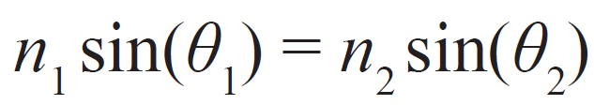

**Starting References**

* [Khan Academy](https://www.khanacademy.org/science/physics/geometric-optics/reflection-refraction/v/refraction-and-snell-s-law)
* [University of Sydney Physics](http://www.physics.usyd.edu.au/teach_res/hsp/sp/mod31/m31_rays.htm)

#### Set 2 - Manipulating light for a purpose

* describe image formation using pinhole cameras and convex and concave lenses
* calculate image positions for thin lenses using either accurate ray tracing scale diagrams and/or the thin lens equation:

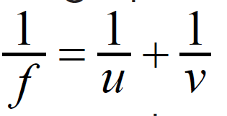

#### Set 3- Manipulating light for a purpose

* calculate image sizes in pinhole and simple lens cameras:
* explain the operation of simple two-lens telescopes and microscopes.

**Starting references**

[Practical Physics](http://practicalphysics.org/pinhole-camera-lens-camera.html)

[Hyperphysics](http://hyperphysics.phy-astr.gsu.edu/hbase/geoopt/teles.html)

#### Set 4 - Light and the eye

* model and explain human vision as refraction at a spherical surface with an adjusting lens
* 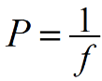distinguish between short-sightedness and long-sightedness, and explain their correction by concave and convex lenses, respectively
* apply the power of a lens (below)to eye glasses

#### Set 5 - Light and the eye

* explain accommodation in the human eye including the effects of ageing
* investigate and explain the treatment of cataract blindness including the use of intraocular lenses
* investigate the operation of the bionic eye.

**Starting references**

* [Hyperphysics](http://hyperphysics.phy-astr.gsu.edu/hbase/geoopt/foclen.html#c1)
* [Khan Academy](https://www.khanacademy.org/test-prep/mcat/physical-sciences-practice/physical-sciences-practice-tut/e/the-refraction-of-light-through-the-human-eye)

# **How do instruments make music?**

In this option students explore models and ideas about sound in the contexts of music and hearing. Students examine how the wave model is applied in the design and development of musical instruments including the voice. They investigate the effects of sound and consider why certain chord progressions and cadences are more appealing to the human ear than others.

On completion of this unit the student should be able to apply a wave model to describe and analyse the production of sound in musical instruments and explain why particular combinations of sounds are more pleasing to the human ear than others.

**Key knowledge**

#### Set 1 - Concepts used to model sound

* describe sound as the transmission of energy via longitudinal pressure waves
* analyse sound using wavelength, frequency and speed of propagation of sound waves: v = f λ
* distinguish between sound intensity (W m-2) and sound intensity level (dB)
* calculate sound intensity at different distances from a source using an inverse square law
* analyse a standing wave as the superposition of a travelling wave and its reflection.

**Starting references**

* [Physics Hypertextbook](https://physics.info/intensity/)

#### Set 2 - Sound production

* explain resonance and identify it as related to the natural frequency of an object
* investigate factors that influence natural frequency including shape and material and explain how this relates to instruments
* investigate and explain the human voice box as a resonance chamber with vibration provided by vocal cords

#### Set 3 - Sound production

* investigate and explain a variety of musical instruments with reference to the similarities and differences of sound production between instrument types (brass, string, woodwind and percussion) and how they compare with the human voice
* analyse, for strings and open and closed resonant tubes, the fundamental and subsequent harmonics and apply this analysis to selected musical instruments
* analyse the unique sound of an instrument as a consequence of multiple resonances created by the instrument and described as timbre
* investigate how the amount of diffraction around an obstacle varies with the size of the obstacle and the wavelength of the sound.

**Starting references**

* [Brittanica](https://www.britannica.com/science/musical-sound)

#### Set 4 - Sound detection

* describe the structure of the human ear with reference to the transfer and amplification of vibrations
* interpret the frequency response curve of the human ear
* differentiate between pitch, timbre and loudness
* identify the representation of timbre as a combination of specific frequencies

#### Set 5 - Sound detection

* describe how particular musical intervals can be represented as ratios of their frequencies, and how consonant frequencies tend to have simple ratios
* investigate the phenomenon of beats.
* investigate an aspect of contemporary research in psychoacoustics.

**Starting references**

* [Psychoacoustics](https://www.izotope.com/en/learn/psychoacoustics-how-perception-influences-music-production.html)

# **How can performance in ball sports be improved?**

In this option students investigate the physics of ball sports using mechanics concepts including Newton’s laws of motion. Students observe and analyse motion in one and two dimensions, study associated collisions and explore the factors that maximise the projection of the ball in various sports. Students may explore ideas in a selected sport of interest or may choose a range of ball sports to investigate.

On completion of this unit the student should be able to apply concepts of linear, rotational and fluid mechanics to explain movement in ball sports.

**Key knowledge**

#### Set 1 - Motion of sports balls

* investigate and calculate theoretically and practically the transfer of momentum in elastic and inelastic collisions (limited to two dimensions) including the use of the coefficient of restitution, e
* investigate and apply theoretically and practically the coefficients of static and kinetic friction to sliding and rolling balls to calculate speeds using Newton’s laws of motion and the equations of constant acceleration
* explain rolling of spherical objects using angular and linear speeds: v = r ω

**Starting references**

* [Sports Training Adviser](https://www.sports-training-adviser.com/lawsofmotion.html)
* Heinemann Physics II Ch 18 p603

#### Set 2 - Maximising flight (1)

* model and describe qualitatively the energy transfers in the action of a double pendulum in at least one of the following:
  + the swing of a racquet, club, stick or bat
  + the throw, pitch or hurl of a ball
  + the kick of a ball
  + calculate air resistance (drag) and terminal velocity:
  + investigate and apply theoretically and practically the equations of constant acceleration to calculate the flight of objects through the air (neglecting air resistance) in two dimensions

#### Set 3 - Maximising flight (2)

* model and describe qualitatively the flight of:
  + a ball through the air when air resistance is not neglected
  + spinning sports balls with reference to the Magnus effect
  + analyse and explain the relative influence of dynamics factors that affect the performance of equipment in ball sports.

**Starting references**

[Sports Training Adviser](https://www.sports-training-adviser.com/lawsofmotion.html)

* [Air resistance](https://www.universetoday.com/73315/what-is-air-resistance/)
* Heinemann Physics II Ch 18 p603

# **How does the human body use electricity?**

In this option students focus on the production of potential difference and subsequent currents in the human body. They explore the role of electricity in nerve transmission, in sensation, and in the heart. The effects of current through the body are considered, including the operation of artificial stimulators and the use of heart defibrillators to restore heart beat. Students investigate an issue related to the production or use of electricity by the body.

On completion of this unit the student should be able to explain the electrical behaviour of the human body and apply electricity concepts to biological contexts.

**Key knowledge**

#### Set 1 - Electrical signals in the human body

* compare charge carriers in the human body (specifically Na+, K+, Ca2+, Mg2+, PO43- and Cl- ions) with those in metals (specifically electrons)
* describe the nervous system as the control of the function of the human body through electrical processes of nerve cells (through an action potential) and chemical transfer between nerve cells (through neurotransmitters diffusing across synapses)
* describe electrical signalling in the body as occurring through electrical pulses

#### Set 2 - Electrical signals in the human body

* model an action potential as a short lasting electrical event across the cell membrane in response to a stimulus, including reference to the roles of ion channels (leakage and voltage gated) in changing membrane potentials during the processes of depolarisation, repolarisation, hyperpolarisation and return to resting state
* explain heart beat with reference to the production of a potential difference
* model heart beat with reference to the action of the nodes in atrial and ventricular muscles as the source of the electric signal, the staggering of signals from the atrial and ventricular muscles, and time delay before both muscles can contract again.

**Starting References**

[BC Campus](https://opentextbc.ca/anatomyandphysiology/chapter/12-4-the-action-potential/)

#### Set 3 - Effects of electricity applied to the body

* describe the general principle of operation of artificial stimulators such as heart pacemakers and cochlear implants
* describe the effects of current through, and potential difference across, the human body
* relate various sensations (tingling, taste) to amplitude of current flowing through the body
* explain how a defibrillator works by storing electric charge for rapid production of large-amplitude current to restore heart rhythm.

**Starting References**

[Rochester Uni](https://www.urmc.rochester.edu/encyclopedia/content.aspx?contenttypeid=85&contentid=p00234)

#### Set 4 - Applications of electricity involving the human body

* apply concepts of resistance and capacitance to current and the frequency of pulses (time constant for charging and discharging, τ = RC )
* apply concepts of current, resistance, potential difference (voltage drop), capacitance and power to the human body (quantitative analysis restricted to use of VIR= and P = VI )

#### Set 5 - Applications of electricity involving the human body

* explain why people have different electrical resistances with reference to comparison of the resistances in human bone, fat, muscle, nerves and skin
* apply electricity concepts to describe one of:
* use of potential difference in biomedical diagnosis with reference to electrocardiograms (ECGs) and/or electroencephalographs (EEGs)
* the galvanic skin response and its use in polygraphs and/or biotherapy feedback devices neuroplasticity after spinal cord injury and use of activity-based therapies
* use of the brain, through activated muscles, to control remote devices
* cauterisation of wounds through resistive heating
* action potentials involved in detecting light by photoreceptors (three types of cones for colour; rods for detecting light and dark changes, shapes and movement).

**Starting References**

* [imotions](https://imotions.com/blog/what-is-eeg/)

# **Example of student work**

# **Research grid**

|  |  |
| --- | --- |
| Option Selected | Aliens |
| Group members | Sienna, Lewis |

|  |
| --- |
| **Insert the dot points for your option and who has been allocated to it.**     * compare **methods of exoplanet detection** including astrometric, radial velocity, transit method and microlensing, referring to databases that differentiate for size, eccentricity and radius     Determining whether a planet is an exoplanet is essential in confirming life beyond earth. Scientists have found 5 methods that all work in unison with each other to list properties of a planet (climate, size, gases). If the properties found are similar to our Earth, or are just classified as habitable then they are called exoplanets (earth like). Then the amount of exoplanets surrounding a star can be inputed into the drake equation to predict the probability of life.     * explain and apply Doppler shift including spectral shift and ‘wobble’ of planetary systems using:     The equation derived known as the doppler shift serves as a base for most methods. Without the Doppler shift, most methods cannot be used and determining an exoplanet without it would be less accurate. The doppler shift refers to wavelength, and the compression and decompression of these waves due to distance. There are many applications but the one to focus on is spectral shift which determines the wobble of a star.     * investigate how the composition of an exoplanet can be determined using spectral analysis.     Determining the chemical composition of a planet is crucial in determining an exoplanet. Spectral analysis collects data on the types of gases and their composition. When interpreting the data, there are two ways comparing if it is habitable. The first is comparing the gases with ones on Earth. The other way is to look for the diversity of gases. More types of gases tell us that life could be present, as life produces gases. Bacteria (which is a form of life) is also known to create or produce more of a certain chemical gas. The more various gases, the more likely it is habitable.    UPDATED: Overall, finding exoplanets is a fundamental tool in discovering life beyond Earth. As we discover each and every new planet, we learn more about the different gases and properties that make a planet habitable. We also know when there is a high chance of life on a planet using spectral analysis, because scientists have determined that a large array of gases mean the possibility that life has formed many of them. |

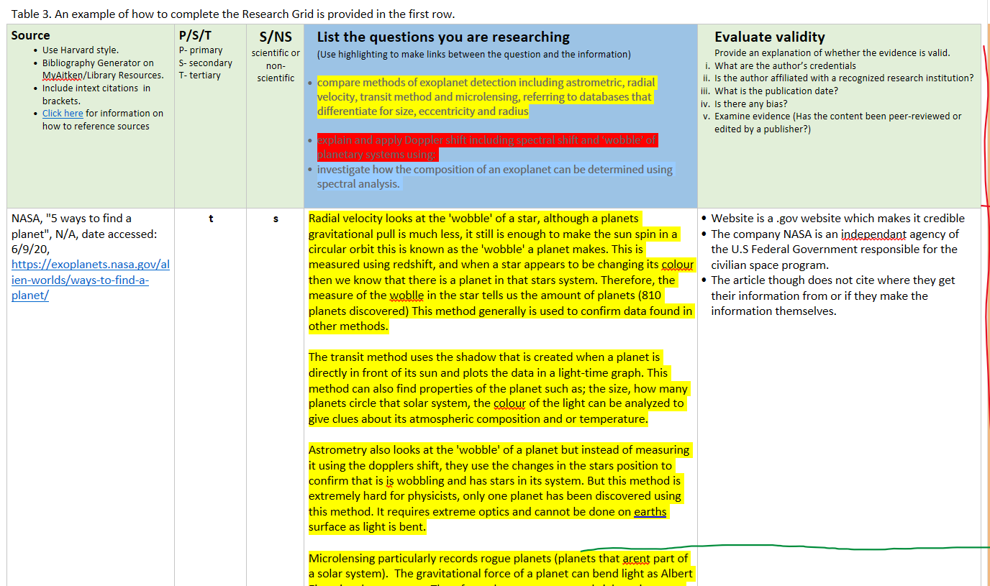

# **Lesson Plan**

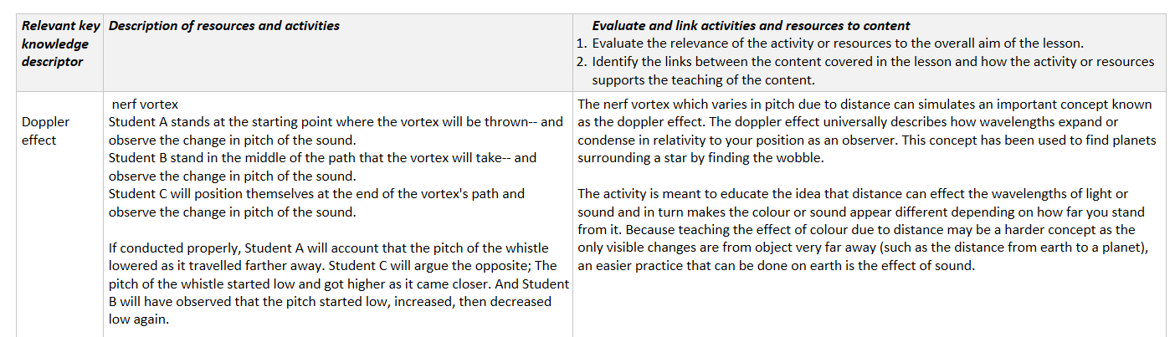

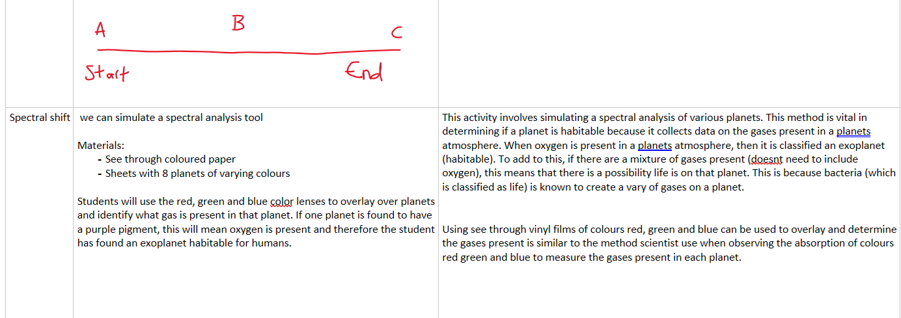

# **Resources prepared by student**

# **Is there life beyond Earth’s Solar System?**

## Finding exoplanets

