**12 Physics Learning Task Powering a City Efficiently**

### **Unit 3 Outcome 3** Analyse and evaluate an electricity generation and distribution system.

**Introduction**

A large wind farm generates electricity using **alternators** that produce **sinusoidal AC voltage** due to the **uniform rotation of coils in a constant magnetic field**. The generated AC voltage has a **frequency of 50 Hz**, a **peak voltage (Vp) of 325V**, and a **peak-to-peak voltage (Vp–p) of 650V**.

As the electricity is transmitted from the wind farm to homes, various challenges arise, such as **power loss in transmission lines, the need for voltage transformation, and the efficiency of AC versus DC power**. Engineers must make critical decisions to ensure power is delivered safely and efficiently.

**Understanding AC Voltage:**

1. How does the frequency of an AC voltage affect its period and overall performance in electrical systems?
2. What factors influence the amplitude and peak-to-peak voltage of an AC source, and how do these values impact energy transmission?

**Comparing AC and DC Power:**

1. How does the **root-mean-square (RMS) voltage** compare to a constant DC voltage in terms of power delivery?
2. In what scenarios would using **DC power** instead of **AC power** be beneficial for electrical transmission or home applications?

**Transformers and Voltage Regulation:**

1. How do transformers play a role in adjusting voltage levels for efficient power transmission?
2. What factors should be considered when designing a transformer to step up voltage for transmission and step it down for residential use?

**Energy Loss and Transmission Efficiency:**

1. Why do power lines experience energy losses, and how does increasing the voltage impact these losses?
2. What are the advantages and challenges of high-voltage transmission in modern power grids?
3. How can new technologies, such as superconducting cables or smart grids, improve the efficiency of power distribution?

**Assessment rubric**

|  |  |  |  |  |
| --- | --- | --- | --- | --- |
|  | 1 | 2 | 3 | 4 |
| **explains concepts** | defines terms e.g. AC is alternating current | explains concepts e.g What is AC voltage? | makes connections between ideas e.g. compares AC with DC | applies understanding to real world scenario |
| **Applies maths principles** | lists formulae | defines variables in formula | Links formulae to relevant concepts | uses relationships in formulae to explain ideas. E.g as P = VI, reducing current reduces power loss |
| **Uses evidence** | states ideas | supports ideas with a physics principle or theory | uses evidence from multiple sources, e.g. calculations and theories | justifies ideas with mathematical models e.g. insert real values into given formula |
| **Communicates ideas** | lists all ideas with unstructured approach | states main idea and then supporting details | uses clear and direct language e.g. eliminates unnecessary words | organises information by using dot points and grouping ideas |
| **Works in a team** | listens to others | explains own thinking and asks questions to clarify understanding | builds on ideas from others | leads others in fostering teamwork |

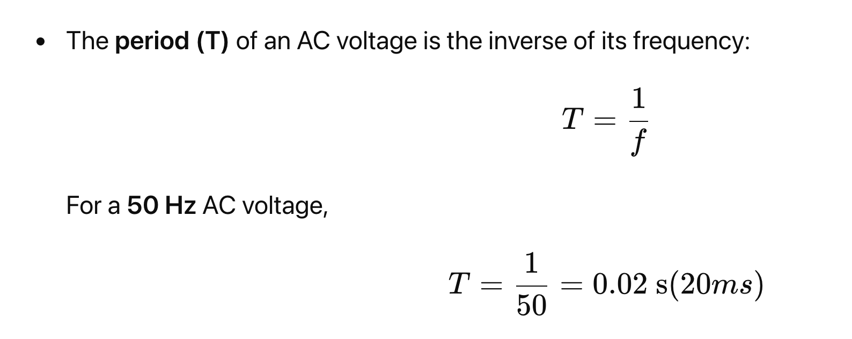

**Suggested answers to the Powering a City Efficiently**

**Understanding AC Voltage**

1. How does the frequency of an AC voltage affect its period and overall performance in electrical systems?

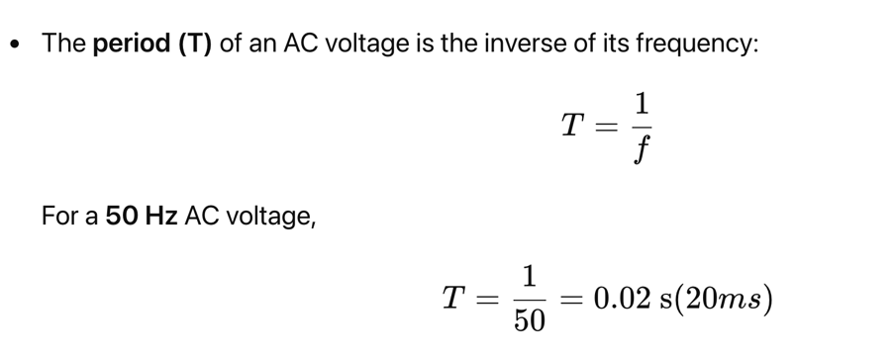

* Higher frequency AC signals allow for **more efficient transformers** and **smaller components** but can cause **higher losses** due to capacitive and inductive effects.
* Lower frequency AC is used in some specialized applications (e.g., 16.7 Hz in railway systems) for different efficiency and operational reasons.

1. What factors influence the amplitude and peak-to-peak voltage of an AC source, and how do these values impact energy transmission?

* The amplitude (peak voltage) depends on:
  + The rotational speed of the generator.
  + The strength of the magnetic field.
  + The number of turns in the coil.
* A higher amplitude means a higher peak-to-peak voltage, which allows for better transmission efficiency but requires proper insulation and safety measures.

**Comparing AC and DC Power**

1. How does the root-mean-square (RMS) voltage compare to a constant DC voltage in terms of power delivery?

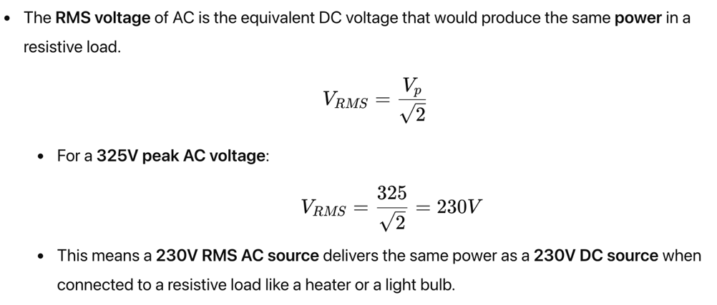

1. In what scenarios would using DC power instead of AC power be beneficial for electrical transmission or home applications?

* Long-distance transmission: High-voltage DC (HVDC) is used for very long distances because it reduces power loss due to lower resistance losses and no reactive power issues.
* Battery-based systems: DC is necessary for solar panels, electric vehicles, and battery storage.
* Sensitive electronics: Computers, LED lights, and many modern appliances use DC internally, so converting AC to DC is necessary

**Transformers and Voltage Regulation**

1. How do transformers play a role in adjusting voltage levels for efficient power transmission?

* Transformers use electromagnetic induction to change AC voltage levels:

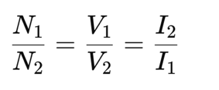

* Step-up transformers increase voltage (reducing current), minimizing energy loss in power lines.
* Step-down transformers decrease voltage for safe household and industrial use.

1. What factors should be considered when designing a transformer to step up voltage for transmission and step it down for residential use?
   * Efficiency: Minimising core and copper losses.
   * Cooling methods: Large transformers require cooling to prevent overheating.
   * Voltage regulation: Keeping voltage stable under different load conditions.

**Energy Loss and Transmission Efficiency**

1. Why do power lines experience energy losses, and how does increasing the voltage impact these losses?

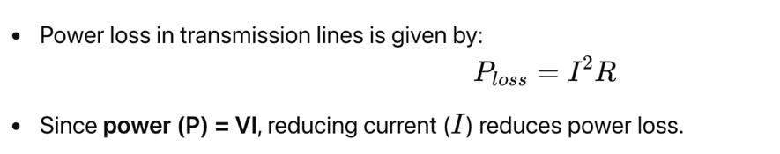

* Since **power (P) = VI**, reducing current (III) reduces power loss.
* **Higher voltage transmission** means **lower current**, reducing losses significantly.

1. What are the advantages and challenges of high-voltage transmission in modern power grids?

* Advantages:
  + Lower power loss over long distances.
  + More efficient energy transmission.
  + Smaller conductor sizes required.
* Challenges:
  + Requires large, expensive transformers.
  + Insulation and safety risks increase at high voltages.

1. How can new technologies, such as superconducting cables or smart grids, improve the efficiency of power distribution?

* Superconducting cables eliminate resistance losses, leading to near-perfect efficiency in transmission.
* Smart grids use AI and automation to optimize power flow, reducing waste and adjusting supply to meet demand dynamically.