12 Physics SAC

Comparison of the Free-Fall Drop Experiment & Pendulum Experiment for Measuring Gravity (g)

Name:_____________________

Unit 3 AOS2

Analyse gravitational, electric and magnetic fields, and apply these to explain the operation of motors and particle accelerators, and the orbits of satellites.

Task Outline
Comparison and evaluation of two methods and/or findings from practical activities.
Both free-fall and pendulum experiments are classical methods for determining the acceleration due to gravity (g). However, they differ in setup, required materials, precision, and sources of error.

SAC conditions
- The practical activities will be completed during class time with the completion of a logbook.
- The SAC write up will be completed under test conditions with a time allocation of 50 minutes.

Relevant Key knowledge descriptors
- analyse the use of gravitational fields to accelerate mass, including:
- gravitational field and gravitational force concepts: $g=G\frac{M}{r^{2}}$ and $F_{g}=G\frac{{m_{1}m}_{2}}{r^{2}}$
- potential energy changes in a uniform gravitational field: E_{g} = mgΔh

Relevant key science skills
- identify independent, dependent and controlled variables in experiments
- formulate hypotheses to focus investigations
- apply relevant occupational health and safety guidelines while undertaking practical investigations
- record and summarise both qualitative and quantitative data, including use of a logbook as an authentication of generated or collated data
- organise and present data in useful and meaningful ways, including tables and graphs
- process quantitative data using appropriate mathematical relationships and units
- use appropriate numbers of significant figures in calculations
- construct graphs that show the relationship between variables
- construct linearised graphs and identify the significance of the gradient (using relationships relevant to the key knowledge outlined in the areas of study)
- identify and analyse experimental data qualitatively, handling, where appropriate, concepts of: accuracy, precision, repeatability, reproducibility, resolution and validity of measurements; and errors (random and systematic)
- identify outliers, and contradictory, provisional or incomplete data
- repeat experiments to evaluate the precision of data
- evaluate investigation methods and possible causes of error and uncertainty, and suggest how precision can be improved, and how uncertainty can be reduced
- identify, describe and explain the limitations of conclusions, including identification of further evidence required
- discuss the implications of research findings evaluate data to determine the degree to which the evidence supports the aim of the investigation, and make recommendations, as appropriate, for modifying or extending the investigation
- discuss relevant physics information, ideas, concepts, theories and models and the connections between them

SAC structure
You will work in a group of four where one pair of students will complete the pendulum experiment and the other will complete the free fall drop experiment. You will need to collate your data and discuss your key findings as a group, ensuring all members understand how to complete both experiments.
The SAC write up will be completed individually under test conditions.

Timeline
Lesson | Content | Date
1 | Background theory, design tables for your experiment
2 | Collect data and share results with other students in group
3 | Analyse data and prepare for SAC write up
4 | Write SAC under test conditions (50 minutes)

Preliminary information

Gravitational field strength, g

(Reference: University of NSW)
Gravity is an attractive non-contact force that emanates from and is exerted on objects with mass. Gravity is applied by means of a gravitational field that surrounds all objects with mass; when an object experiences gravity, it is often referred to as its weight.
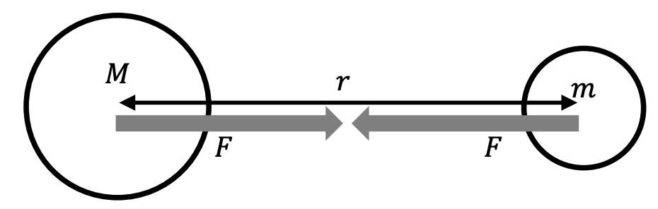
The strength of the force between two objects with masses M and m is given by
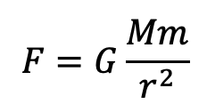
where r is the distance between the centres of the objects and G is the universal gravitational constant, 6.67 × 10^{–11} N m² kg^{–2}.
The geometry of the gravitational field is such that its strength decreases in proportion to the inverse of the square of distance (i.e. obeys the inverse square law).
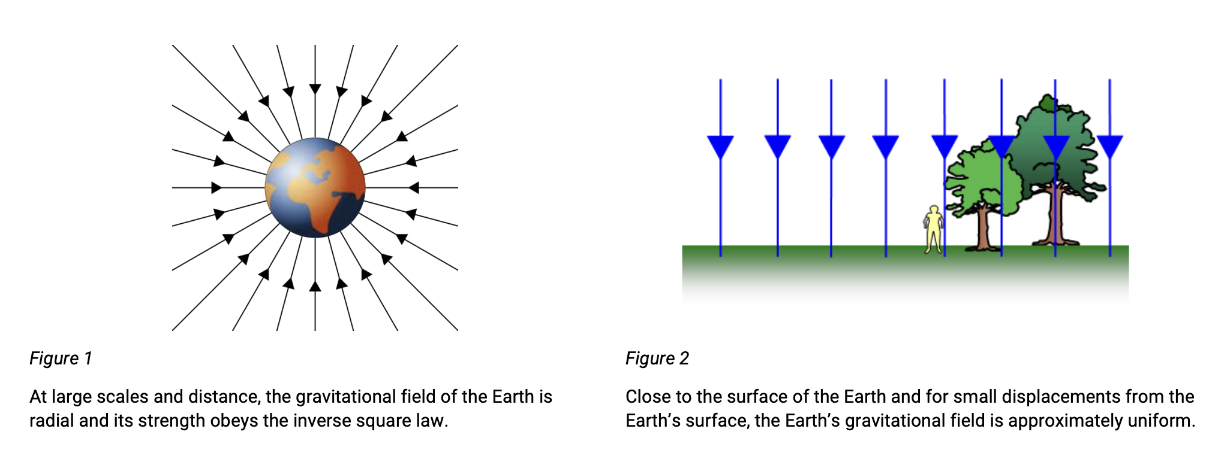

On Earth, we feel the Earth pulling down on us, but we do not seem to feel the Earth being pulled up towards us. This is because the Earth is much more massive than we are. In the situation where a small object is nearby to a large dominant object, then we can simplify the situation to one where we just focus on the behaviour of the smaller object in the gravitational field of the larger one. The weight of an object with mass, m, can be determined using the simplified equation F = mg. where g is the gravitational field strength. On Earth’s surface, this value is commonly accepted as about 9.8 N kg^{–1}

Question 1
Show that surface gravitational field strength can be given by the equation, $g= \frac{GM}{r^{2}}$

The Pendulum Experiment
A pendulum can be used to measure the local gravitational field strength. The pendulum we will use consists of a mass at one end of a string, with the other end fixed to a stand. The length of the pendulum can be varied.
It has been shown that the period of a pendulum T (the time to complete one back and forth swing) is related to its length, l. The mass of the pendulum and the angle of the swing (for small angles) does not affect its period.
The equation for the pendulum’s period is $T=2π \sqrt{\frac{l}{g}}$
where g is gravitational field strength. In this experiment, we will be finding a value for g using linear regression (i.e. by using a line of best fit).

Question 2
In order to obtain a line of best fit, the pendulum equation needs to be linearized. Rearrange the equation into the form that resembles the general equation for a straight line, y = mx + c, where y = l and x = T².

Question 3
Which variables should be plotted along the horizontal and the vertical axes of the graph?

Question 4
Write an expression that relates the gradient of this graph with gravitational field strength, g.

Aim
Aim Checklist
States what will be done and measured
Uses a verb to begin sentence

The aim states the purpose of the experiment. In the aim, you need to explain what will be done, and how it will be measured. The sentence should also start with a verb, such as “to investigate, to measure, to verify, to determine, to compare or to calculate.”
______________________________________________________________________________________________________________________________________________________________________________________________

Variables
Identify the independent, dependent and controlled variables. Use the table below as a guide.
Independent Variable  (what will you be changing?) | Dependent variable  (what change will you be measuring? Include units) | Controlled variables  (What will you keep constant? – You will need at least 5 controlled variables)

Hypothesis
A hypothesis is a prediction about the relationship that you expect to occur between your IV and DV. It must be written using the following sentence structure. If independent variable increases/decreases then dependent variable increases/decreases because….insert theory to justify your hypothesis
__________________________________________________________________________________________________________________________________________________________________________________________________________________________________________________________________________________________________________________________________________________________________________________________

Hypothesis Checklist
Show the link between independent and dependent variables
Includes theory to justify your hypothesis

Materials
- 0.5 kg mass
- 1.5 m, 1.0 m and 0.5 m length of string
- retort stand
- clamp
- protractor
- stop watch

Procedure
- Attach the retort stand on the bench with a clamp, and add a boss head and clamp.
- Attach the mass to the string and tie to the end of the clamp.
- Complete 5 replicates of the pendulum oscillating 5 times for a pendulum string length of 1.5 m. Calculate the period by diving by 5.
- Repeat step 3 for the pendulum string length of 1.0 m and 0.5 m.

Results
Design a table to record your results.

Graph
Use excel to graph your results.

Calculations
Use the gradient of the line from the graph of L vs T² to determine g.

Free fall investigation
Free fall is the motion of an object under the influence of gravity alone, with negligible air resistance. According to Newton’s Second Law of Motion, the force acting on a freely falling object is given by: F = ma
For an object of mass, m, in free fall, the only force acting is its weight due to gravity: F = mg
Since F = ma we equate: mg = ma
This simplifies to: a = g
indicating that all objects accelerate at the same rate, g, regardless of their mass, in the absence of air resistance.

Kinematic Equations and Gravity
For an object dropped from rest (v₀ = 0), its motion is described by the kinematic equation:
h = v₀t + ½ gt² as v₀ = 0, this simplifies to:
h = ½ gt² and rearranging for g: $g = \frac{2h}{t^{2}}$

Aim
Aim Checklist
States what will be done and measured
Uses a verb to begin sentence

The aim states the purpose of the experiment. In the aim, you need to explain what will be done, and how it will be measured. The sentence should also start with a verb, such as “to investigate, to measure, to verify, to determine, to compare or to calculate.”
______________________________________________________________________________________________________________________________________________________________________________________________

Variables
Identify the independent, dependent and controlled variables. Use the table below as a guide.
Independent Variable  (what will you be changing?) | Dependent variable  (what change will you be measuring? Include units) | Controlled variables  (What will you keep constant? – You will need at least 5 controlled variables)

Hypothesis
A hypothesis is a prediction about the relationship that you expect to occur between your IV and DV. It must be written using the following sentence structure. If independent variable increases/decreases then dependent variable increases/decreases because….insert theory to justify your hypothesis
__________________________________________________________________________________________________________________________________________________________________________________________________________________________________________________________________________________________________________________________________________________________________________________________

Hypothesis Checklist
Show the link between independent and dependent variables
Includes theory to justify your hypothesis

Materials
- Meter stick or tape measure
- Stopwatch
- Small dense object (e.g., steel ball)
- Motion sensors (optional for increased precision)

Procedure
- Measure and mark different heights, h, from which the object will be dropped.
- Release the object from rest, ensuring no initial push is given.
- Use a stopwatch to measure the time, t, from release to impact. Repeat.
- Perform the experiment for at least five different heights.

Results
Design a table to record your results.

Calculations
- Using the kinematic equation: $g = \frac{2h}{t^{2}}$ , calculate the acceleration due to gravity for each trial.
- Plot height, h, against t². The slope of the best-fit line should be approximately $\frac{g}{2}$

Graph
Use excel to graph your results.

Comparison of two methods for measuring gravity, g
Practical A: Pendulum investigation |  | Practical B: Free fall drop experiment
Principle used  Objects in free fall undergo uniform acceleration due to gravity. |  | Principle used  A swinging pendulum follows simple harmonic motion governed by gravity.
Measurement variables |  | Measurement variables
Independent Variable |  | Independent Variable
Dependent Variable |  | Dependent Variable
Hypothesis |  | Hypothesis
Sources of random error |  | Sources of random error
Sources of systematic error |  | Sources of systematic error
Quality of collected data |  | Quality of collected data
Suitability for different environments |  | Suitability for different environments

U3O2 Comparison and evaluation of two methods and findings from practical activities
Task instructions
Complete an evaluation of the two experiments in 50 minutes under test conditions.
You are allowed a pen, pencil, ruler, eraser, scientific calculator and your experimental logbook.

Question 1
Summarise the data from both experiments and evaluate the quality of the data.

______________________________________________________________________________________________________________________________________________________________________________________________

______________________________________________________________________________________________________________________________________________________________________________________________

______________________________________________________________________________________________________________________________________________________________________________________________

______________________________________________________________________________________________________________________________________________________________________________________________

Question 2
Use science theories to explain your key findings.

______________________________________________________________________________________________________________________________________________________________________________________________

______________________________________________________________________________________________________________________________________________________________________________________________

______________________________________________________________________________________________________________________________________________________________________________________________

______________________________________________________________________________________________________________________________________________________________________________________________

______________________________________________________________________________________________________________________________________________________________________________________________

______________________________________________________________________________________________________________________________________________________________________________________________

Question 3
Identify a random error and a systematic error for each experiment which have a substantial effect on the quality of the data. Justify your answer by referring to the relevant measurement terms.

______________________________________________________________________________________________________________________________________________________________________________________________

______________________________________________________________________________________________________________________________________________________________________________________________

______________________________________________________________________________________________________________________________________________________________________________________________

______________________________________________________________________________________________________________________________________________________________________________________________

______________________________________________________________________________________________________________________________________________________________________________________________

______________________________________________________________________________________________________________________________________________________________________________________________

______________________________________________________________________________________________________________________________________________________________________________________________

______________________________________________________________________________________________________________________________________________________________________________________________

______________________________________________________________________________________________________________________________________________________________________________________________

______________________________________________________________________________________________________________________________________________________________________________________________

Question 4
Explain how the equation, E_{g} = mgΔh, can be used to determine the velocity of the mass at the lowest point in the pendulum experiment and just before the mass hits the ground in the free fall drop experiment. Support your answer with calculations.

______________________________________________________________________________________________________________________________________________________________________________________________

______________________________________________________________________________________________________________________________________________________________________________________________

______________________________________________________________________________________________________________________________________________________________________________________________

______________________________________________________________________________________________________________________________________________________________________________________________

______________________________________________________________________________________________________________________________________________________________________________________________

______________________________________________________________________________________________________________________________________________________________________________________________

______________________________________________________________________________________________________________________________________________________________________________________________

Question 5
Evaluate which experiment would be most suitable to measure gravity, g, in the following environments:
- International space station
- Mars
- Stawell Underground Physics Laboratory
Justify your answer by referring to the practicalities of the experimental procedure and quality of the collected data.

______________________________________________________________________________________________________________________________________________________________________________________________

______________________________________________________________________________________________________________________________________________________________________________________________

______________________________________________________________________________________________________________________________________________________________________________________________

______________________________________________________________________________________________________________________________________________________________________________________________

______________________________________________________________________________________________________________________________________________________________________________________________

______________________________________________________________________________________________________________________________________________________________________________________________

______________________________________________________________________________________________________________________________________________________________________________________________

______________________________________________________________________________________________________________________________________________________________________________________________

______________________________________________________________________________________________________________________________________________________________________________________________

______________________________________________________________________________________________________________________________________________________________________________________________

______________________________________________________________________________________________________________________________________________________________________________________________

